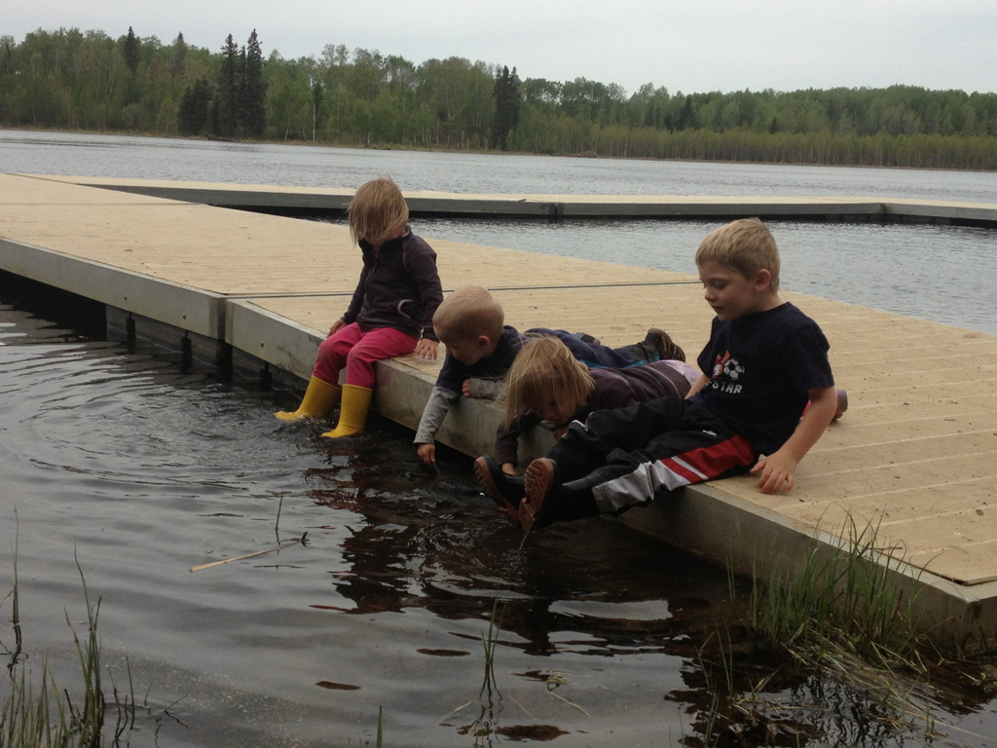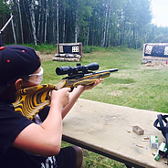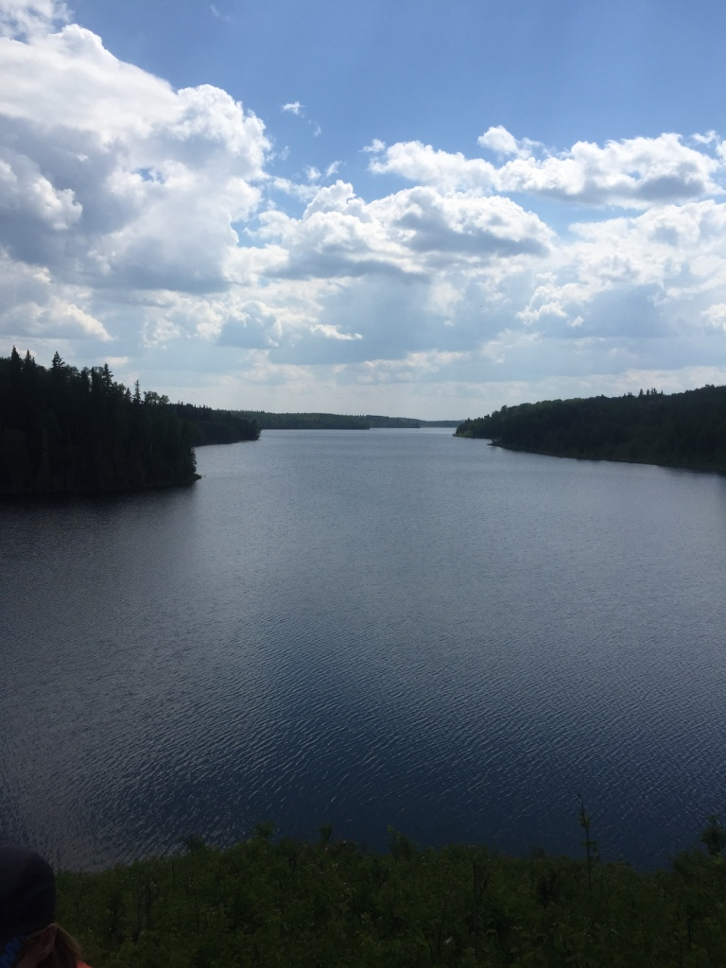√

Join us …

Monday, September 5, 2016

# Free activities, refreshments and information at member facilities

* 1 – 5 pm Camp Wright Cadet Camp: Event information
* 1 – 3 pm Forfar Recreation Park: Lakes information
* 1 – 3 pm Long Lake Outdoor Centre: Paddle Boarding, kayaking and nature crafts
* 2 – 4 pm Narrow Lake Conservation Centre: Archery and shooting
* 3 – 5 pm Camp Wright Cadet Camp: Voyageur canoeing
* 4 – 5 pm Camp Wright Cadet Camp: Hot dogs and wind-up

Contact

Doug: [dougfrost.djf@gmail.com](mailto:dougfrost.djf@gmail.com)

Juanita: [juanitamarois@mcsnet.ca](mailto:juanitamarois@mcsnet.ca)

